**HOME FUSION:**

**SMART HOME SMARTER LIFES**

Minor Project Report submitted in partial fulfilment of the requirement for the award of degree of

In

Electronics and Communication Engineering Under the Supervision of

Dr. Richa Gupta

### By

Adarsh Goyal (36115002821)

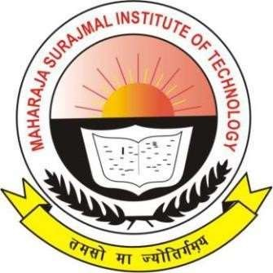

**MAHARAJA SURAJMAL INSTITUTE OF TECHNOLOGY**

C-4, Janakpuri, New Delhi-110058

Affiliated to Guru Gobind Singh Indraprastha University, Delhi

November 2024